**ELECTRIC MACHINES LABORATORY**

**LIST OF EXPERIMENTS**

|  |  |  |
| --- | --- | --- |
| **EXPERIMENT #** | **EXPERIMENT TITLE** | **Page No** |
| 1 | **DC Machine Winding Resistance:**  ***Objectives:***   1. ***Find the ohmic resistance of the exciter winding in a DC motor*** 2. ***Find the ohmic resistance of armature winding.*** | 3 |
| 2 | **DC Shunt Motor:**  ***Objectives:***   1. ***Study & analyze the connection and operation of Shunt wound.*** 2. ***Speed measurement of shunt wound motor*** | 6 |
| 3 | **DC Series & Compound Motor:**  ***Objectives:***   1. ***Analyze connection & operation of series wound motor.*** 2. ***Analyze connection & operation of compound wound motor.*** | 9 |
| 4 | **Controlling of DC Machine:**  ***Objectives:***   1. ***Speed control by adding resistance in armature circuit*** 2. ***Speed control via changing armature & exciter voltage*** 3. ***DC motor direction Control*** | 13 |
| 5 | **DC Motor Braking:**  ***Objective:***  ***To study Rheostatic Braking.*** | 19 |
| 6 | **Slip ring Machine with shorted &unconnected rotor winding:**  ***Objectives:***   1. ***Slip ring machines with unconnected rotor windings*** 2. ***Slip ring machines with shorted rotor windings.*** 3. ***Voltage at rotor for unconnected rotor winding.*** | 23 |
| 7 | **Slip Ring Machines with starting resistors:**  ***Objectives:***   1. ***Slip ring machines with starting resistors.*** 2. ***ii) Measurements of voltage on stator and rotor.*** | 30 |
| 8 | **Stepping Motor in full step mode:**  ***Objectives:***   1. ***Step angle & steps/revolution calculation in full step mode..*** 2. ***Determine the step angle in full step mode.*** 3. ***Determine the maximum frequency in full step mode.*** | 34 |
| 9 | **Stepping Motor in Full Step Mode:**  ***Objectives:***   1. ***Find maximum start frequency in full step mode.*** 2. ***Control signals in full step mode.*** 3. ***Direction control of stepping motor in full step mode*** | 39 |
| 10 | **Stepping Motor in Half Step Mode:**  ***Objective:***  ***Control signals in half step mode.*** | 44 |
| 11 | **Linear Motor :**  ***Objective:***  ***Measure the induced voltage in linear motor.*** | 46 |
| 12 | **Motor Constant for Linear Motor:**  ***Objective:***  ***Find Motor constant of Linear motor.*** | 54 |
| 13 | **3 Phase Linear Motor:**  ***Objectives:***   1. ***Measurement of induced voltage - slow movement*** 2. ***Linear motor with three phase variable voltage.*** 3. ***Linear motor with variable 3 phase frequency.*** | 58 |
| 14 | **BLDC Motor:**  ***Objectives:***   1. ***Cogging Torque*** 2. ***Switching States*** | 64 |

|  |  |
| --- | --- |
| **Name** | Muhammad Asad |
| **Reg. #** | 2019-EE-383 |
| **Marks** |  |

**EXPERIMENT NO 1**

**Iron losses & Copper losses of a single phase transformer**

**Objectives:**

1. To find out the iron losses of a single phase transformer (open circuit test).
2. To find out the copper losses of a single phase transformer (short circuit test).

**Apparatus:**

1. Voltmeter (0 – 300V)
2. Ammeter (0 – 2A)
3. Wattmeter (0 – 120 W)

**Circuit Diagram**

**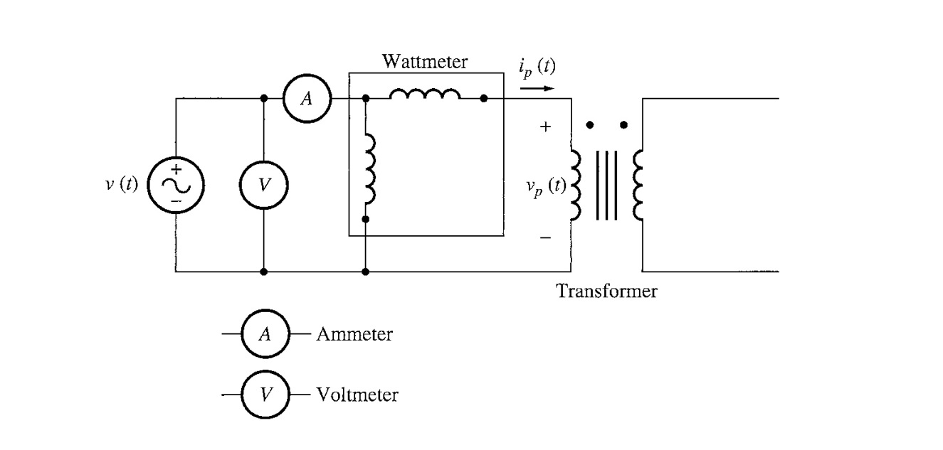**

**Open-circuit Test**

**Theory & Procedure:**

The purpose of this test is to determine no load loss or core loss and no load current Io, which is helpful in finding Xo and Ro.One winding of the transformer whichever is convenient but usually low voltage windings left open and the other is connected to its supply of normal volt and frequency. A wattmeter, voltmeter and ammeter are connected in high voltage winding i.e. Primary winding in the present case. Normal voltage is applied to primary normal flux will be set up in the core hence normal iron loss will occur which are recorded by the wattmeter. As the primary no load Io is small usually 2-10% of rated load current Cu losses is negligible small in primary I will in secondary b/c it is open. Therefore the wattmeter reading will show practically core loss under no load condition.

**Observations:**

|  |  |  |  |
| --- | --- | --- | --- |
| **Sr.no** | **W (watts)** | **V (Volts)** | **Io (Ampere)** |
| **1.** | 3W | 109 V rms | 0.06 A rms |
| **2.** | 5W | 109 V rms | 0.06 A rms |

**For all loads:-**

Cos φ = W /VI

Iw = Io Cos φ

Iμ = Io Sin φ

Xo = V/Iμ

Ro = V/ Iw

Zo = (R2 + Xo2)1/2

**Readings:**

**Open Circuit:**

**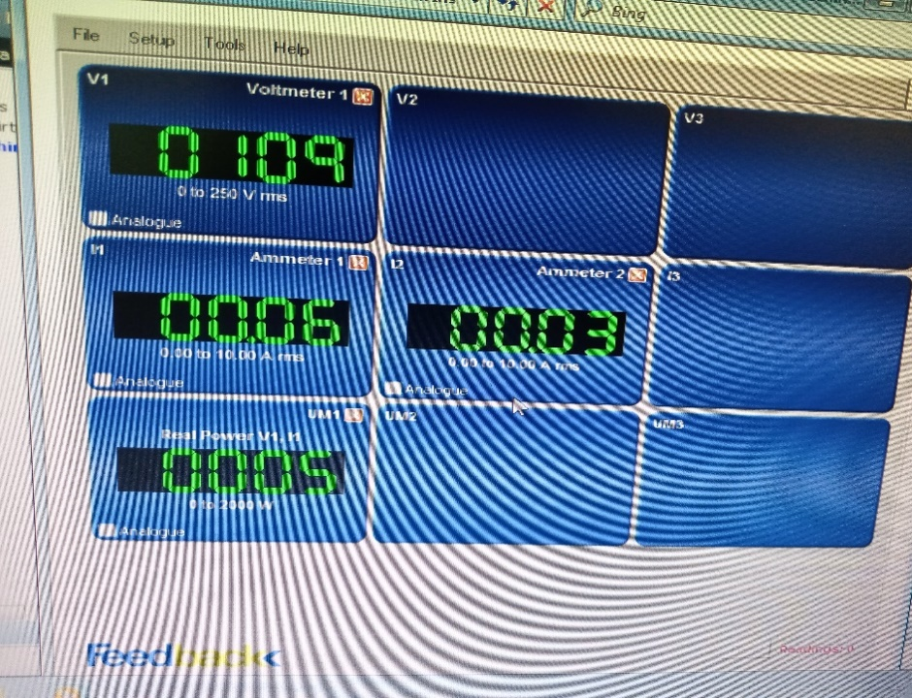**

**Circuit diagram:**

**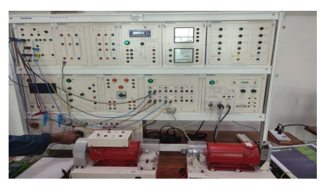**

**Calculations:­­**

**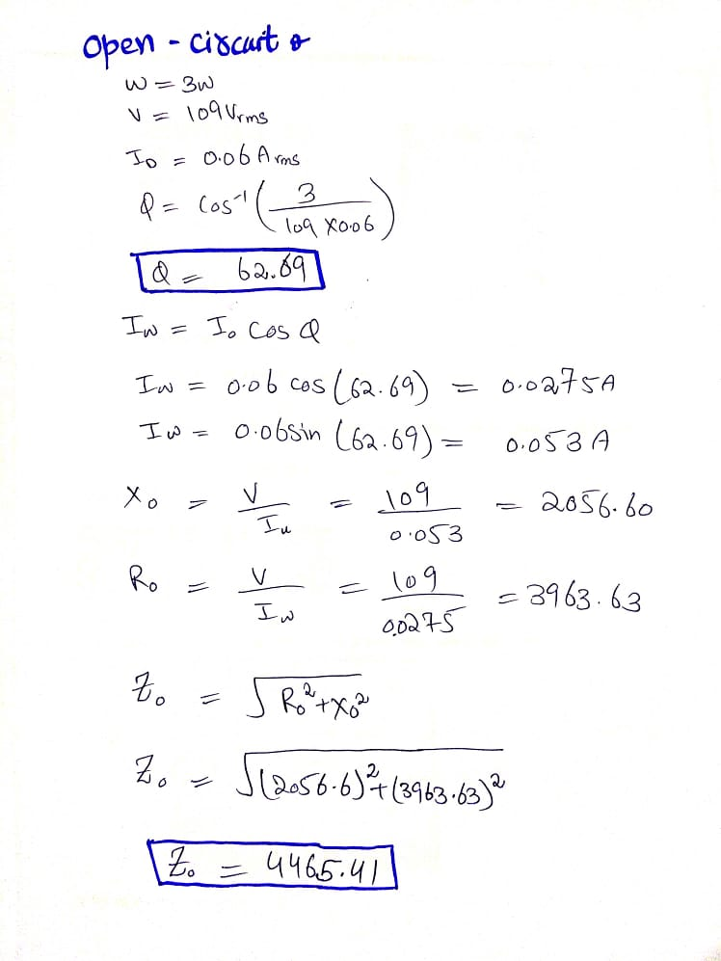**

**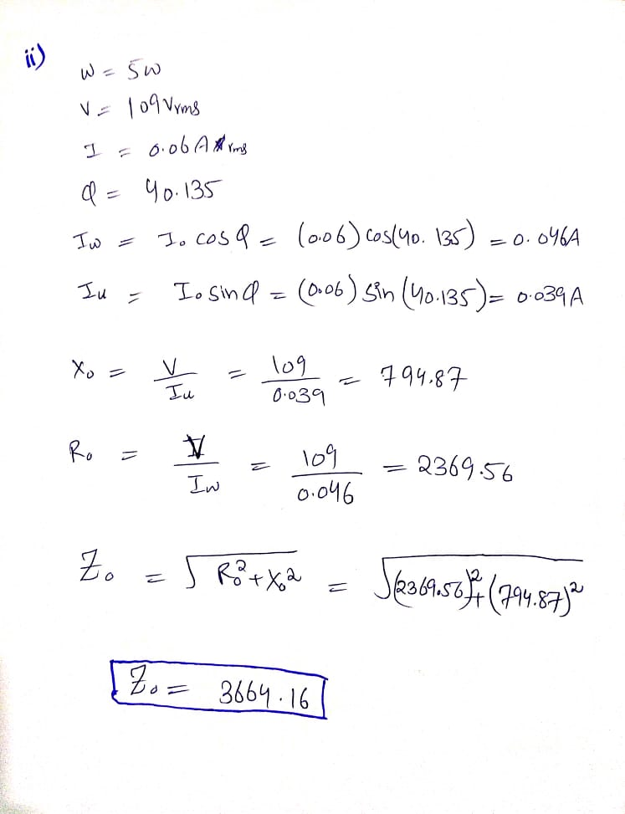**

**Result:**

The iron losses of single phase transformer are \_\_\_\_\_\_3\_\_\_\_\_ watt.

**Objectives:**

**To find out the Cu losses of a single phase transformer by short circuit test.**

**Apparatus:**

1. Voltmeter (0-15V)
2. Wattmeter (0-750)
3. Ammeter (0-15A)

**Circuit Diagram:**

***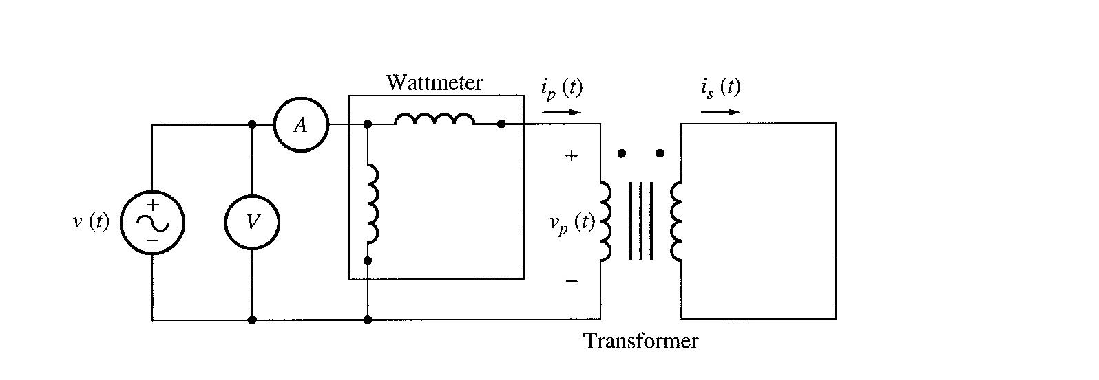***

**Short-circuit Test**

**Theory & Procedure:**

In this test one winding (usually low voltage winding) is short circuited by a thick conductor or by means of ammeter (Which may serve an additional purpose of indicating rated load). A low voltage (5-10% of the normal voltage) at normal frequency is applied to the primary and gradually increased, till full load current is flowing in both primary and secondary.Since in this test the applied voltage is a small percentage of the normal voltage the mutual flux produced is also a small percentage of its normal value. Hence core losses are very small with the result the Wattmeter reading represents the full load copper loss.

**Observations:**

|  |  |  |  |
| --- | --- | --- | --- |
| **Sr.No** | **W (watts)** | **Vsc (Volts)** | **Isc (Ampere)** |
| **1.** | 3W | 17 V rms | 0.43 A rms |
| **2.** | 3W | 16 V rms | 0.43 A rms |

Vsc=Short circuit voltage or voltage required to calculate load

Z01 = Vsc / I1

W = I12 x R01

R01 = W / I12

X01 = [(Z01)2 – (R01)2] ½

This test is economical for finding out:

• Equivalent impedance Z01

• Equivalent leakage resistance R01

• Equivalent resistance of the transformer.

• Cu losses at full load or at any desired load can be calculated.

• Knowing Z01 the total voltage drop in the transformer can be

**Readings:**

**Short Circuit:**

|  |
| --- |
| **C:\Users\Muham\Desktop\IMG_20210713_134238_873.jpg**  **C:\Users\Muham\Desktop\IMG_20210713_134229_696.jpg** |

**Circuit diagram:**

**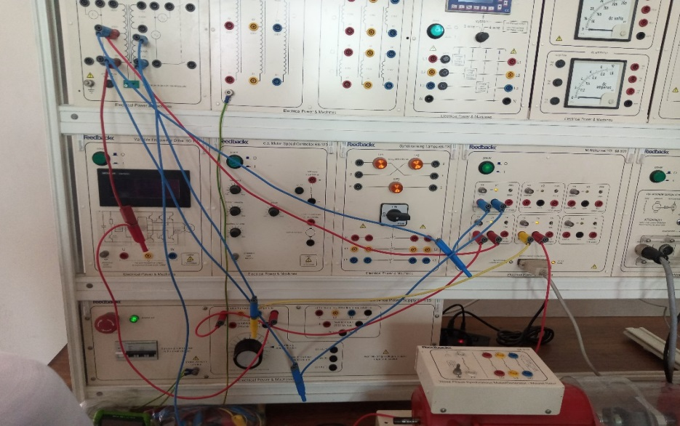**

Calculated which is helpful in finding voltage regulation.

**Calculations:**

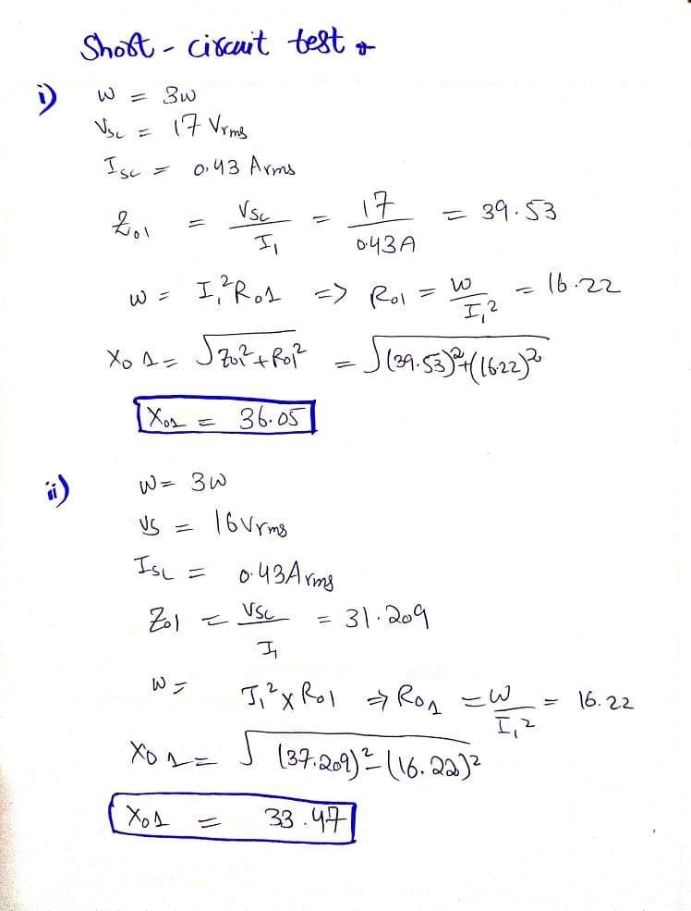

**Result:**

The copper losses of single phase transformer are\_\_\_\_\_\_3\_\_\_\_ Watts.

|  |  |
| --- | --- |
| **Name** | Muhammad Asad |
| **Reg. #** | 2019-EE-383 |
| **Marks** |  |

**EXPERIMENT # 2**

**Efficiency and voltage regulation of a Single phase step down transformer**

**Objective:**

To find out the efficiency and voltage regulation of a Single phase step down transformer

****

**Circuit diagram for Single phase step down transformer**

**Apparatus:**

1. Two Voltmeters (0 - 300V), (0 - 150V)
2. Two Ammeters (0 - 1A)
3. Step-down transformer
4. Variable Load

**Theory:**

A step-down transformer converts the high voltage at primary side to a lower level at the secondary side. Works on the principle of mutual induction, the transformer secondary winding has an induced e.m.f. due to the voltage across the primary winding.As the number of turns in the secondary winding are less than the number of turns in the primary winding, hence the magnitude of the induced e.m.f. in the secondary winding is less than that in primary (as e.m.f. induced varies directly with number of turns).

**Efficiency of Transformer:**

The ratio of Vsls and Vplp  gives the efficiency of the transformer and the formula for efficiency and voltage regulation are:

**η = ( VsIs / VpIp ) x 100**

**%VR = [ ( VSN – VSL) / VSN ] x 100**

**Procedure:**

1. Make the connections as shown in diagram.
2. Switch on the AC supply and read the no load secondary voltage when there is no load turned ON.
3. Now turn on the load on the secondary side and take readings at different loads.

**Observation & Calculations:**

No load secondary voltage VSN = 80Volts

|  |  |  |  |  |
| --- | --- | --- | --- | --- |
| **Sr.No.** | **Vp (Volts)** | **Ip (A)** | **Vs (Volts)** | **Is (A)** |
| **1.** | 80 Vrms | 0.07Arms | 44 Vrms | 0.03 Arms |
| **2.** | 80 Vrms | 0.07Arms | 43 Vrms | 0.03 Arms |

**η% = ( VsIs / VpIp ) x 100**

η% = (1.32/5.6) x 100

η% = 23.57%

η = 23.57

η% = (1.29/5.6) x 100

η% = 23.04%

η = 23.04

**%VR = [ ( VSN – VSL) / VSN ] x 100**

%VR = [ ( 80 – 43) / 80 ] x 100

VR = 46.25

**%VR = [ ( VSN – VSL) / VSN ] x 100**

%VR = [ ( 80 – 44) / 80 ] x 100

VR = 45

**Readings:**

**With Load:**

**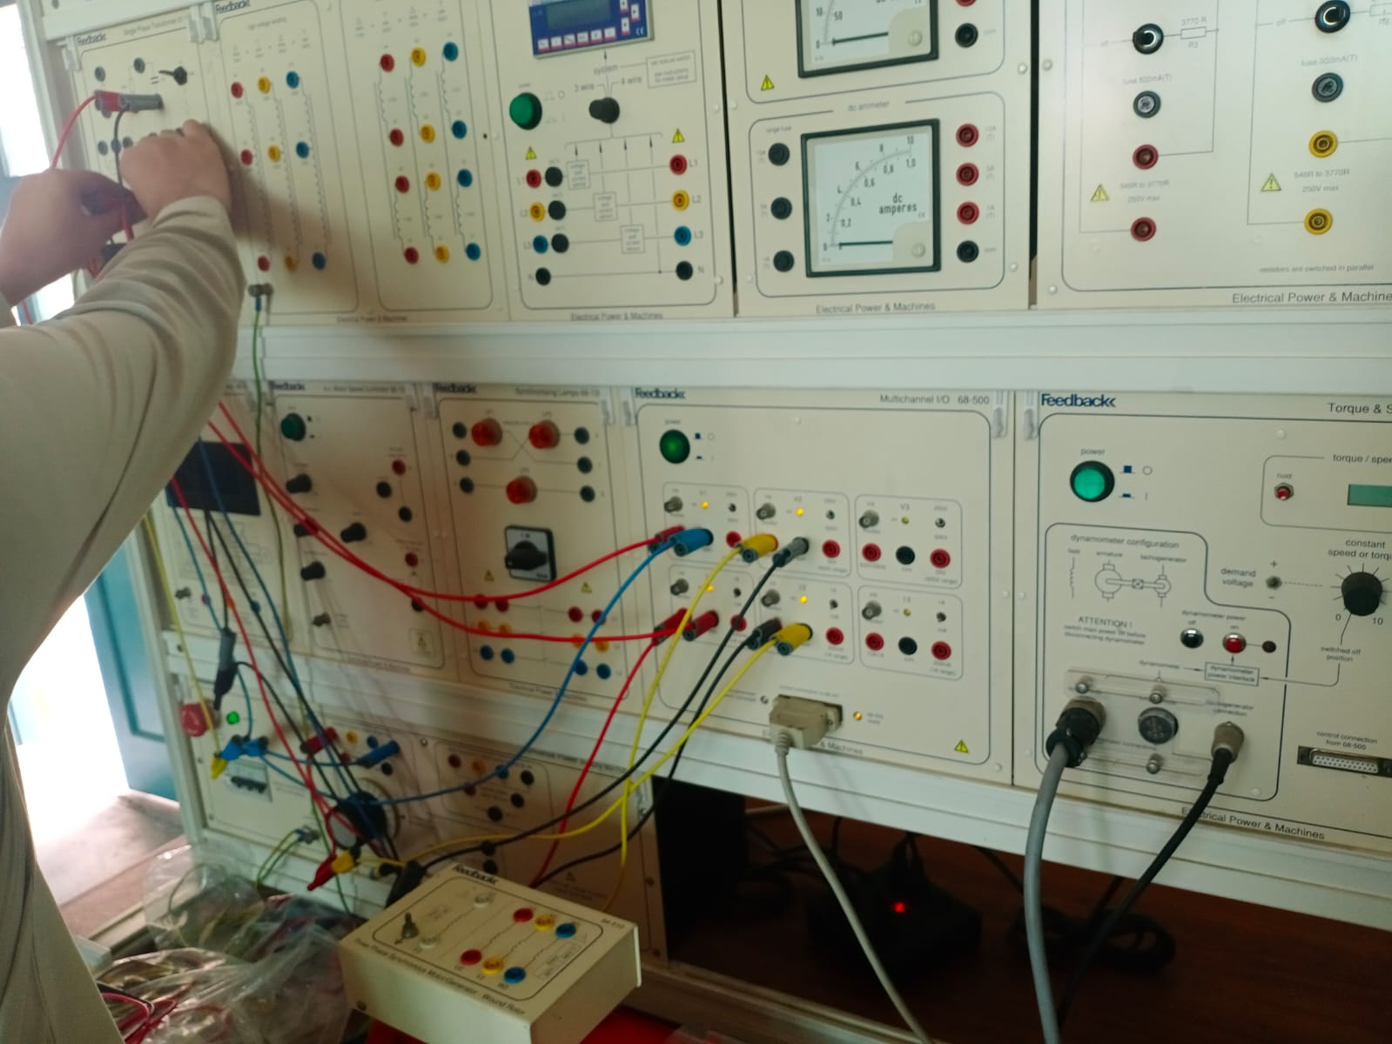**

**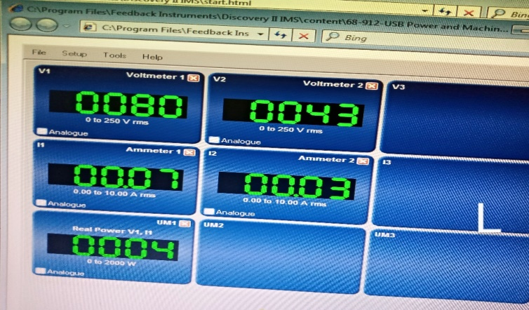**

**With No Load:**

**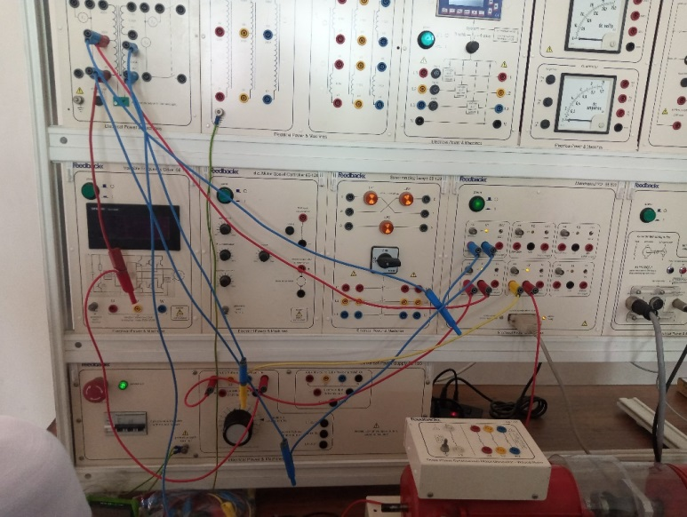**

**Result:**

**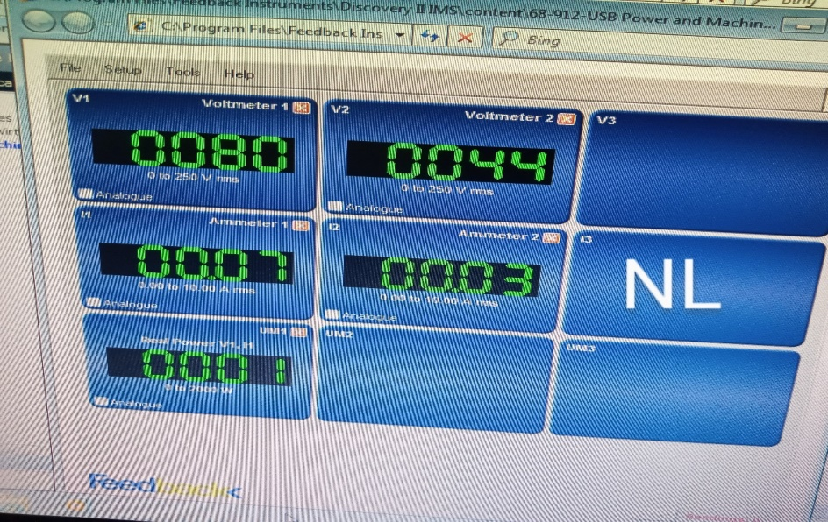**   
The efficiency and voltage regulation have been calculated and observed

to increases with load.

**Precautions:**

1. Connections should be tight and neat.

2. Ammeters should always be connected in series.

3. Voltmeters should always be connected in parallel.

|  |  |
| --- | --- |
| **Name** | Muhammad Asad |
| **Reg. #** | 2019-EE-383 |
| **Marks** |  |

**EXPERIMENT # 3**

**Objective:**

To study the effect of filed excitation on the generation of voltage by an alternator (open circuit magnetization curve).

**Apparatus:**

1. One Voltmeter ( 0 – 600V)
2. One Ammeter ( 0 – 1.2A )
3. One frequency meter
4. D.C. Supply (220 V)
5. Field Rheostat

**Circuit Diagram**

**Circuit Diagram for Magnetization curve of Alternator**

**Theory:**

In A.C. generator (alternator), the stationary armature is called stator, the rotating field is called rotor

The advantages are

* It is easy to insulate the stationary armature windings for very high voltages.
* It is easy to collect the high voltage from a fixed terminal.
* Stator is outside of the rotor (fixed in yoke), so more space is available for 3-phase winding. Direct current is necessary for excitation, voltage is low and so small power is supplied through slip rings.

**Procedure:**

1. Make the connections as shown in diagram, run it at rated speed 1500 rpm.
2. Note the line voltage at zero excitation.
3. Connect the field to D.C. source through an ammeter and excite it. Increase the excitation current every time.
4. Tabulate the readings and draw the open circuit characteristics (O.C.C.) Or no load magnetization curve.

**Observations:**

|  |  |  |
| --- | --- | --- |
| **Sr.No.** | **Rotor Field Excitation**  **Current (If) Amperes** | **Terminal Voltage**  **(Vt) Volts** |
| **1** | 0.08A | 86.3 V |
| **2** | 0.10A | 119.3V |
| **3** | 0.12A | 191.3V |
| **4** | 0.14A | 219V |
| **5** | 0.16A | 269V |
| **6** | 0.18A | 330V |
| **7** | 0.20A | 378V |

**Readings:**

|  |  |
| --- | --- |
| **C:\Users\Muham\Desktop\IMG_20210714_132725_903.jpg** | **C:\Users\Muham\Desktop\IMG_20210714_132730_738.jpg** |
| **C:\Users\Muham\Desktop\IMG_20210714_132741_054.jpg** | **C:\Users\Muham\Desktop\IMG_20210714_132745_705.jpg** |
| **C:\Users\Muham\Desktop\IMG_20210714_132805_117.jpg** | **C:\Users\Muham\Desktop\IMG_20210714_132809_927.jpg** |
| **C:\Users\Muham\Desktop\IMG_20210714_132820_806.jpg** | **C:\Users\Muham\Desktop\IMG_20210714_132826_905.jpg** |
| **C:\Users\Muham\Desktop\IMG_20210714_132842_061.jpg** | **C:\Users\Muham\Desktop\IMG_20210714_132848_372.jpg** |

|  |  |
| --- | --- |
| **C:\Users\Muham\Desktop\IMG_20210714_132908_537.jpg** | **C:\Users\Muham\Desktop\IMG_20210714_132913_511.jpg** |
| **C:\Users\Muham\Desktop\IMG_20210714_132936_528.jpg** | **C:\Users\Muham\Desktop\IMG_20210714_132940_979.jpg** |

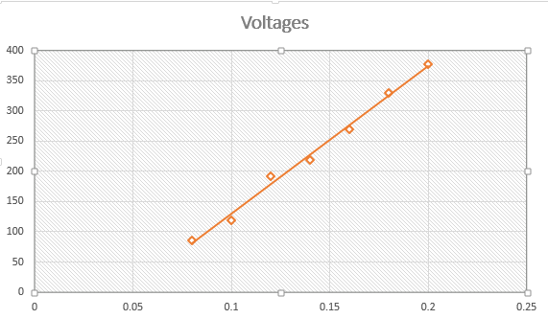**Magnetization curve**

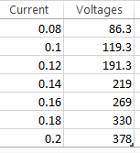

**Result:**

Voltage increases directly for low exciting current and the curve then bends at higher excitation indicating the effect of saturation.

**Precautions:**

1. Maintain the alternator speed constant throughout.
2. Note the readings carefully every time. When the exciting current is increased.

|  |  |
| --- | --- |
| **Name** | Muhammad Asad |
| **Reg. #** | 2019-EE-383 |
| **Marks** |  |

**EXPERIMENT # 7(a)**

**Shunt Wound DC Motor**

**Objectives:**

* 1. Connection and operation Shunt wound motor.
  2. Speed measurement of shunt wound DC motor.

**Apparatus:**

1. DC motor card
2. Lucas-Nulle unitrain module
3. PC
4. Connecting wires

**Theory:**

Shunt wound is a type of dc motor in which both exciter and armature windings are separately excited. This motor is mostly used for constant speed applications as speed slightly varies with change in torque.

**i)Connection & Operation**

**Procedure:**

1. In this experiment the DC machine is operated as a shunt-wound machine (separately excited).
2. Set up the apparatus as shown in the fig 7.1 shunt wound arrangement. The shaft of the rotor is inserted into the bearing situated in the stator. When attaching the rotor make sure that the attachment pin is inserted into the socket labeled 0°.
3. Now open the DC Motor Control virtual instrument from INSTRUMENTS/MOTOR CONTROLS menu. Set this instrument to 12.0 Volts.
4. Switch on the POWER button of the power supply.

**Circuit Diagram:**

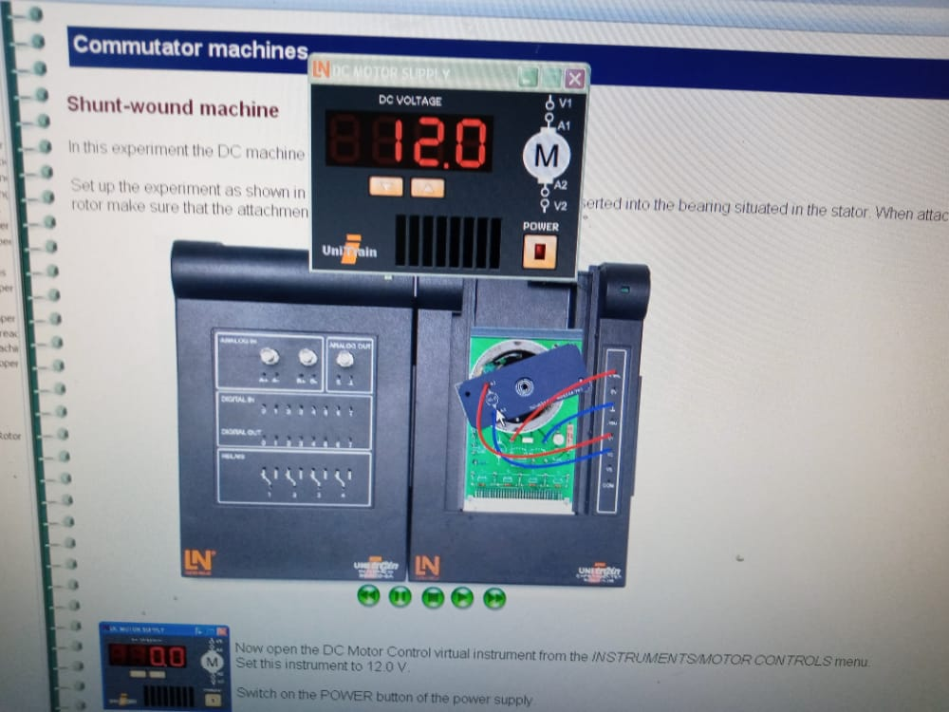

F**ig 7.1 Circuit Arrangement for shunt wound machine.**

**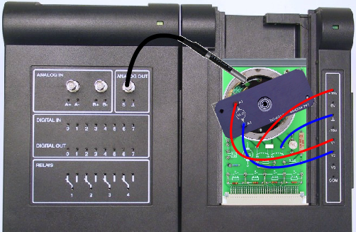Conclusions:** Describe your observations and comments in space below**.**

**ii)Speed Measurement:**

**Procedure:**

1. In this experiment we will perform a contactless measurement of the rotation speed of a DC shunt-wound machine using a stroboscope.
2. The previous experiment set-up of fig 7.1 is retained. It is supplemented with the stroboscope, which illuminates the rotor with a flash of light but does not make physical contact with it. Stroboscope is connected at analogue output socket.
3. Now open the virtual instrument DC Motor Supply from the INSTRUMENTS/MOTORCONTROLmenu. Set it to 12.0 V. Then switch the POWER button on.
4. Now go to the INSTRUMENTS menu & open Stroboscope virtual instrument. Set the flash rate to 30 Hz. Switch the stroboscopes POWER button on.
5. Point the flash bulb at the rotating armature.
6. Slowly increase the flash rate until you can see the motion appear to stand quite still.

**Observations:**

Note the flash rate at which motor appears still and also write down the corresponding speed for this flash rate.

Read off the speed:\_\_\_\_\_\_\_\_\_\_RPM

Flash Rate:\_\_\_\_\_\_\_\_\_\_\_Hz

**Lab Exercise:**

***Task 7.1:*** Try to find out whether the motion also appears stationary at half or double the frequency and also describe its reason**.**

**Conclusions:** Describe your observations and comments in space below**.**

|  |  |
| --- | --- |
| **Name** | Muhammad Asad |
| **Reg. #** | 2019-EE-383 |
| **Marks** |  |

**EXPERIMENT # 7(b)**

**Series & Compound Wound DC Motor**

**Objectives:**

* 1. Analyze connection & operation of series wound motor.
  2. Analyze connection & operation of compound wound motor

**Apparatus:**

1. DC motor card
2. Lucas-Nulle unitrain module
3. PC
4. Connecting wires

**Theory:**

DC Series motor is a type of DC motor in which both shunt and exciter windings are connected in series while compound motor is another type which have the characteristics of both series and shunt wound machines.

**i)Series Wound Machine:**

**Procedure:**

1. In this experiment the DC machine is operated as a series -wound machine.
2. Set up the apparatus as shown in the fig 7.1(b). The shaft of the rotor is inserted into the bearing situated in the stator. When attaching the rotor make sure that the attachment pin is inserted into the socket labeled 0°.
3. Now open the DC Motor Control virtual instrument from INSTRUMENTS/MOTOR CONTROLS menu. Set this instrument to 18.0 V. Switch on the POWER button of the power supply.
4. Connect stroboscope and find out motor speed in this configuration.

**Circuit Diagram:**

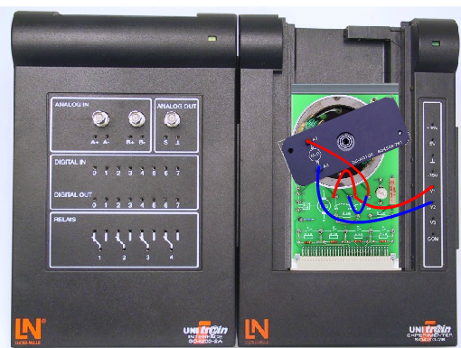

Fig 7.1(b) Circuit Arrangement for Series Wound

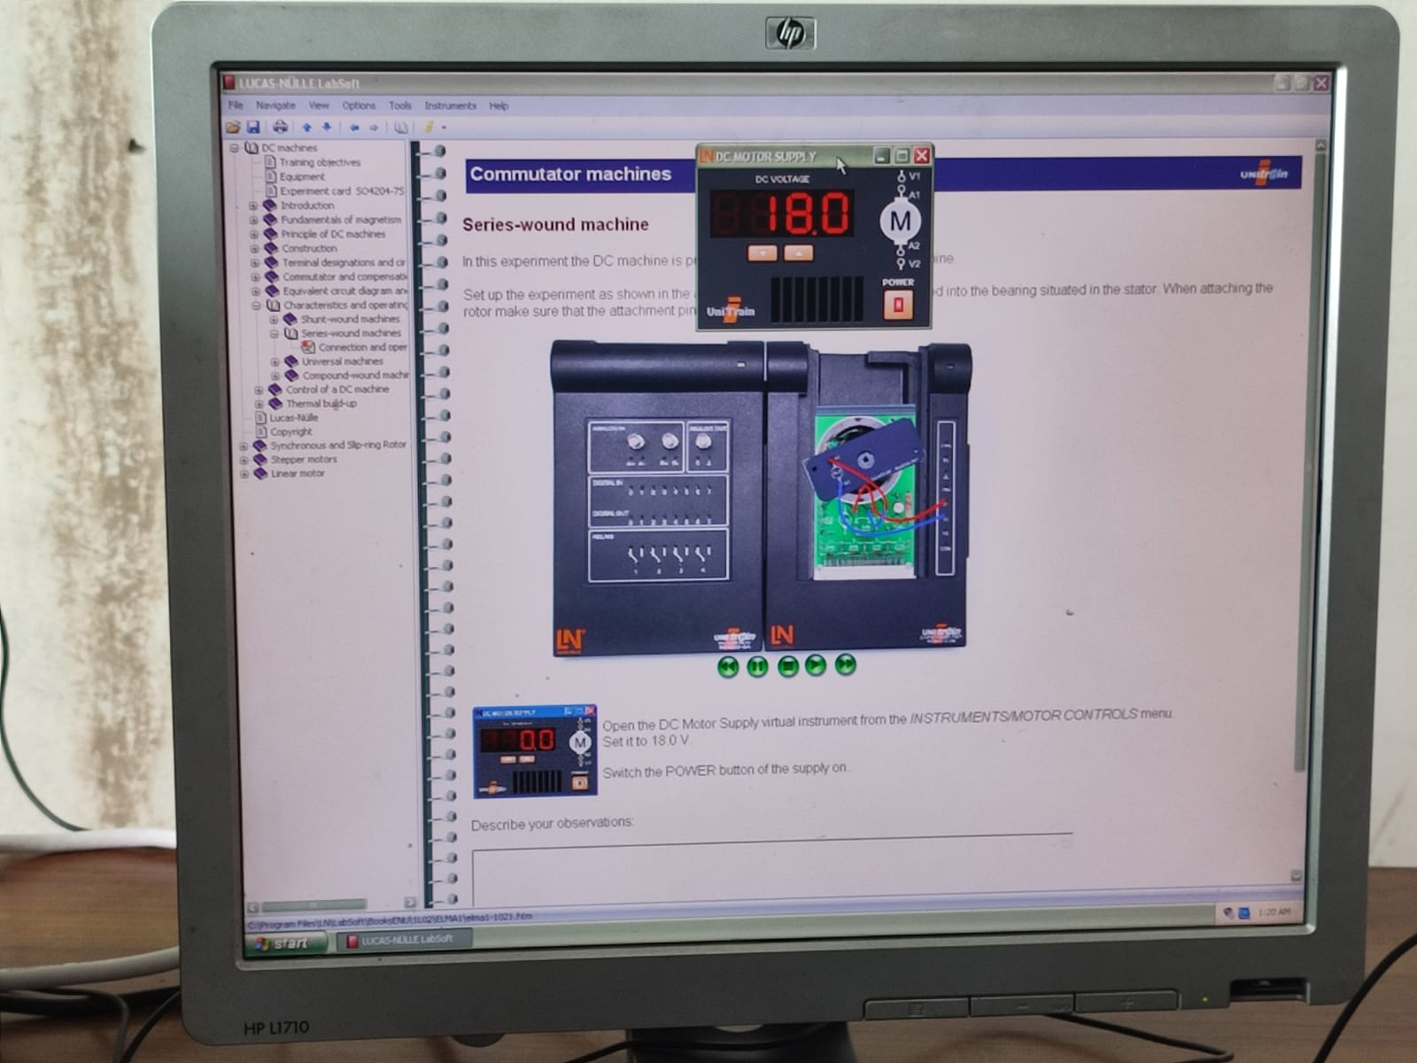

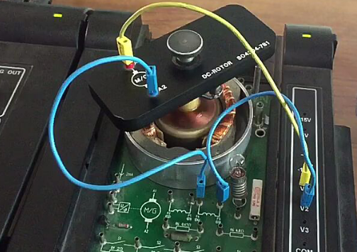

**Observations:**

Applied Voltage:\_\_18\_\_Volts

**Conclusions:** Describe your observations and comments in the space provided.

**ii)Compound Wound Machine:**

**Procedure:**

1. In this experiment the DC machine is operated as a compound-wound machine.
2. Set up the apparatus as shown in the fig 7.2(b). The shaft of the rotor is inserted into the bearing situated in the stator. When attaching the rotor make sure that the attachment pin is inserted into the socket labelled 0°.
3. Now open the DC Motor Control virtual instrument from INSTRUMENTS/MOTOR CONTROLS menu. Set this instrument to 18.0 V. Switch on the POWER button of the power supply.
4. Connect stroboscope and find out motor speed in this configuration.

**Circuit Diagram:**

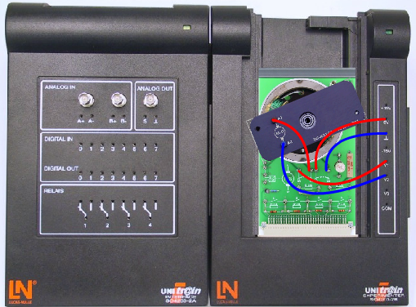

Fig 7.2(b) Circuit Arrangement for Compound Wound

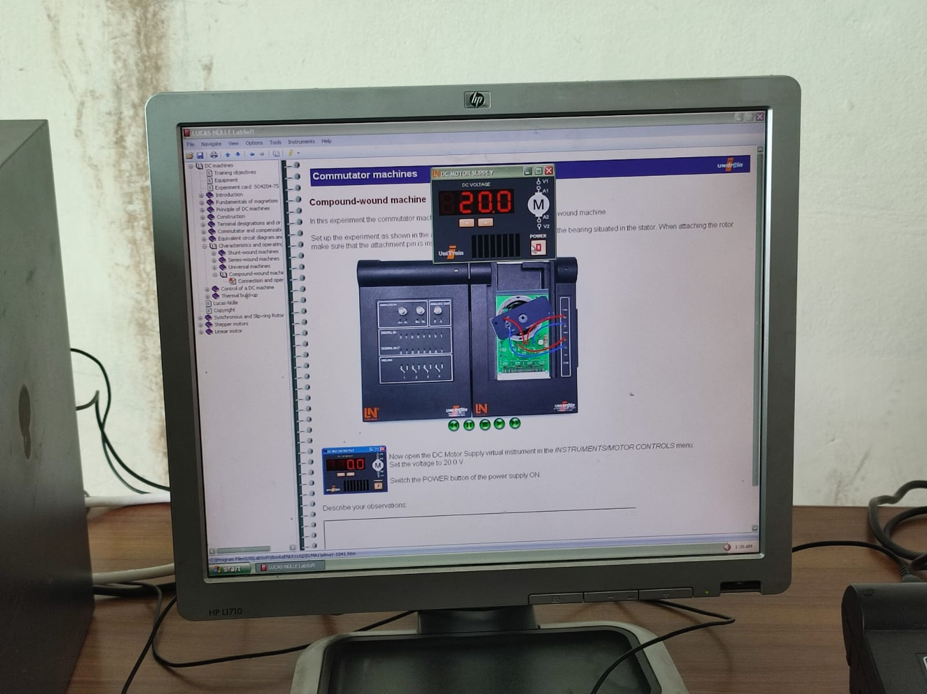

**Observations:**

Applied Voltage:\_\_\_\_20\_\_\_\_Volts

**Lab Exercise:**

***Task 7.1(b):*** Make a speed comparison between shunt wound,compound wound and series wound machines**.**

**Circuit diagram:**

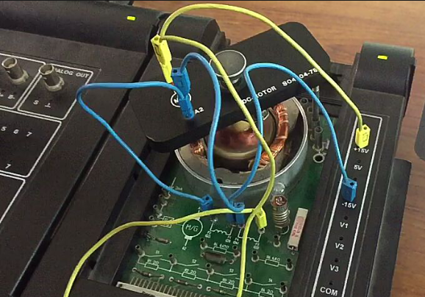

**Conclusions: Describe your observations and comments in the space provided.**

|  |  |
| --- | --- |
| **Name** | Muhammad Asad |
| **Reg. #** | 2019-EE-383 |
| **Marks** |  |

**EXPERIMENT # 7(c)**

**Control of DC Motor**

**Objectives:**

* 1. Speed control via adding resistance in armature circuit
  2. Speed control via changing armature & exciter voltage
  3. DC motor direction Control

**Apparatus:**

1. DC motor card
2. Lucas-Nulle unitrain module
3. PC
4. Connecting wires

**Theory:**

DC machines can be controlled via different ways. In this lab we will control direction and speed of DC motor. Firstly we are controlling speed via adding a resistor in armature voltage which will in turn change the armature current and finally this current reduction will change the speed. Secondly we are varying the armature and exciter voltage. Varying exciter voltage will change the magnetic field strength which results in change of Lorentz force and ultimately in speed variation.

In motor operating mode the direction of rotation can be reversed either by reversing the poles of the armature voltage or by reversing the poles of the exciter voltage. Both methods lead to the same result

**i)Series resistance in the armature:**

**Procedure:**

1. In this experiment we will investigate the influence of armature series resistance on the rotation speed of a DC shunt-wound machine.
2. Set up the experiment as shown in the fig 7.1(c). The shaft of the rotor is inserted into the bearing situated in the stator. When attaching the rotor bear in mind that the attachment pin is inserted into the socket labeled 0°.
3. Now open the DC Motor Supply virtual instrument from the *INSTRUMENTS/MOTOR CONTROLS* menu.
4. Set the amplitude to an initial level of 15 V. Switch the POWER button of the power supply ON.
5. Attach Stroboscope and find out the speed with attached resistance configuration.

**Circuit Diagram:**

**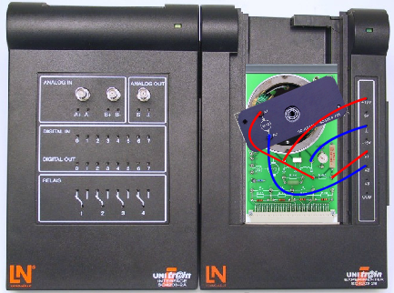**

**Fig 7.1(c) Series resistance with armature winding**

**Observations:**

Applied Voltage: 12 Volts

Flash Rate: 50Hz

Speed: 3000 RPM

**Result:**

****

**Lab Exercise:**

***Task 7.1(c):*** Now use a short cable to shunt the resistor R6 and disconnect it again after several seconds. What effects does the armature resistor have on the speed?

**Conclusions:** Describe your observations and comments in the space provided.

**ii)Control via changing armature & exciter voltage:**

**Procedure:**

1. In this experiment we will measure the influence of the armature voltage on the rotation speed of a DC shunt-wound machine.
2. A contactless measurement of the rotation speed will be performed using the stroboscope.
3. Connect the machine in shunt wound configuration fig 7.2(c).
4. The shaft of the rotor is inserted into the bearing situated in the stator. When attaching the rotor make sure that the attachment pin is inserted into the socket labeled 0°.
5. Now open the DC Motor Supply virtual instrument from the INSTRUMENTS/MOTOR CONTROL menu. Set the amplitude to an initial value of 20 V. Switch the POWER button of the power supply ON.
6. Now open the Stroboscope virtual instrument from the INSTRUMENTS menu.
7. Set the flash rate for the first measurement to the initial value of 100 Hz and then reduce this gradually until the motion appears to be stationary.  Switch the POWER button of the stroboscope ON.
8. Point the strobe at the rotating armature and use the standard methods to perform the speed measurements using the values of the armature voltage specified in the table:
9. Find out speed at different values of armature and exciter voltage and place in table.
10. Repeat the same experiment to measure the influence of the exciter voltage on the rotation speed of a DC shunt-wound machine.
11. The procedure is same just replace fixed supply of field winding with variable supply of armature winding. Now open the DC Motor Supply virtual instrument from the INSTRUMENTS/MOTOR CONTROLSmenu.Set the amplitude to an initial value of 15 V. Switch the POWER button of the power supply ON.
12. Now open the Stroboscope virtual instrument from the INSTRUMENTS menu. Set the flash rate to30 Hz. Switch the stroboscope's POWER button ON.
13. ****Point the strobe at the rotating armature and use the standard method to measure the speed using the values of the armature voltage specified in the table.

**Circuit Diagram:**

F**ig 7.2(c) Circuit Arrangement for shunt wound machine**

**Lab Exercises:**

***Task 7.2(c):*** Draw a graph between armature voltage and speed and append it on the page & also describe relationship of armature voltage with speed.

***Task 7.3(c)*:** Draw a graph between exciter voltage and speed and append it on the page. & also describe relationship of exciter voltage with speed.

***Task 7.4(c):*** Describe relationship of armature voltage & exciter voltage with rotation speed in the space given below.

**Conclusions:** Describe your observations and comments in the space below.

**iii)Reversing rotation direction:**

**Procedure:**

1. In this experiment we will be exploring the possibilities of reversing the direction of rotation of a DC shunt-wound machine.
2. Set up the motor in shunt wound configuration as in fig 7.2(c). The rotor shaft is inserted into the bearing situated in the stator. When attaching the rotor make sure that the attachment pin is inserted into the socket labelled 0°.
3. Now open the DC Motor Supply virtual instrument from the INSTRUMENTS/MOTOR CONTROLS menu. Set the voltage to 12.0 V. Switch the POWER button of the power supply ON.
4. Observe the direction of rotation of the machine using different power supply configurations and then check the appropriate check boxes. To "change" a connection simply interchange the two connections of the exciter or armature winding.

**Observations:**

|  |  |
| --- | --- |
| **Connection of the windings** | **Rotation direction of the machine** |
| Armature winding unchanged  Exciter winding unchanged | Clockwise  Anti-clockwise |
| Armature winding changed  Exciter winding unchanged | Clockwise  Counterclockwise |
| Armature winding unchanged  Exciter winding changed | Clockwise  Anti-clockwise |
| Armature winding changed  Exciter winding changed | Clockwise  Anti-clockwise |

**Lab Exercise:**

***Task 7.5(c):*** Explain why an increase in rotation speed in response to field weakening does not occur as expected with this machine

**Conclusions: Describe your observations and comments in space given below.**

|  |  |
| --- | --- |
| **Name** | Muhammad Asad |
| **Reg. #** | 2019-EE-383 |
| **Marks** |  |

**EXPERIMENT # 10 (a )**

**Slip Ring (Wound Rotor Induction Motor) with Shorted & Unconnected Rotor Winding**

**Objectives:**

* 1. Slip ring machines with unconnected rotor windings
  2. Slip ring machines with shorted rotor windings.
  3. Voltage at rotor for unconnected rotor winding.

**Apparatus:**

1. Slip ring machine card
2. Lucas-Nulle unitrain module
3. PC
4. Connecting wires

**Theory:**

**10.1: Induction Motor Types**

1. squirrel-cage 2.Slip Ring

In induction machines a distinction is drawn between machines with squirrel-cage rotors and those with slip-ring rotors. In terms of physical response and in the design of the stator, slip-ring rotor machines do not differ in any way from squirrel-cage.  
However it is the rotors of the machines which are different, having considerable dissimilarities in their construction.

**10.2: Principal differences between slip-ring rotor and squirrel-cage machines**

A squirrel-cage rotor (left) has a winding in the form of individual rods, which are connected at both ends via short-circuit rings. There is no other way to access the rotor winding from outside and thus no possibility of influencing the rotor's operating response as shown in figure 10.1. A slip-ring rotor, like its stator, is equipped with a "real" three-phase winding which is connected in the standard three-phase star configuration. These windings are represented in the diagram as three single windings shown in three different colors one color per winding. The ends of the rotating three-phase windings are connected to the slip-rings, on which carbon brushes impinge. The terminals of the carbon brushes are connected up to terminal panel. Thus the rotor winding ends, as well as the ends of the stator winding, are accessible at the terminal for connection to a circuit. The operating response of the rotor can be modified as a function of and in accordance with the circuit configuration.

**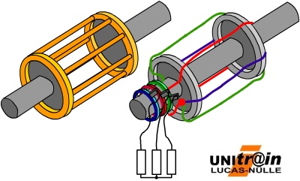**

Fig 10.1 Induction Motor Types

Normally the rotor winding is completely short-circuited after run-up using resistors.

The following holds true for the speed in all induction machines:

|  |  |
| --- | --- |
| formel1 | where:  p = number of pole pairs f1 = frequency of the stator voltage being applied s = slip |

It implies that the following means can be used to change the motor's speed:

* Change the number of pole pairs p, e.g. in pole-changing motors
* Change the frequency f1 of the motor's supply voltage
* Modify the slip s by changing the stator voltage
* Modify the slip s by making changes to the rotor

**i)Slip ring Machines with Unconnected rotor windings**

**Procedure:**

1. In this experiment the response of the slip-ring rotor machine is demonstrated with disconnected rotor windings. Set up the apparatus as shown in figure 10.2.
2. Open the virtual instrument *3-phase Power Supply*from the *Instruments Power Supplies* menu. Carry out the following settings:
3. U = 11 V
4. f = 50 Hz
5. Press the POWER button

**Circuit Diagram:**

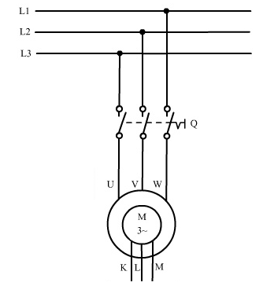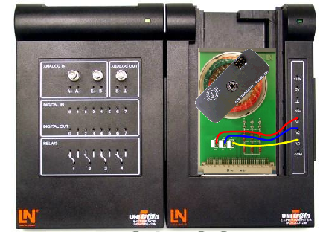

**Fig 10.2 Slip Ring machines with unconnected rotor windings**

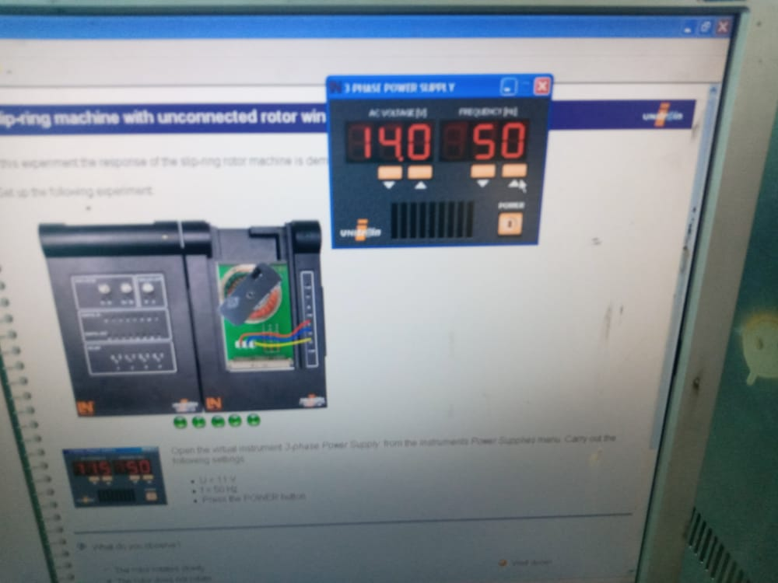

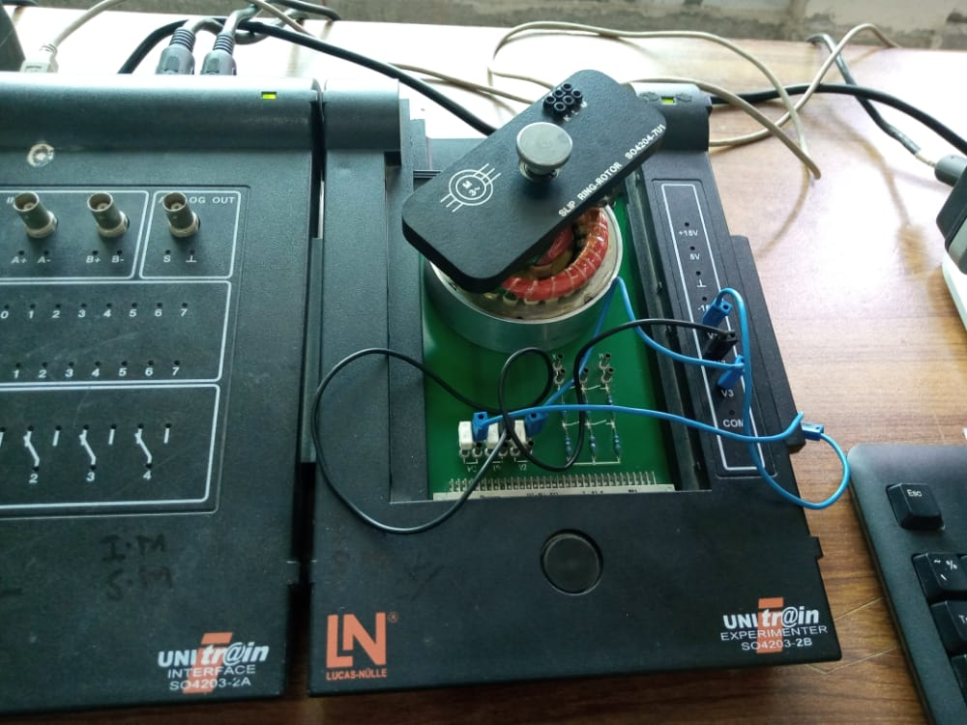

**Observations:**

**Q. What do you observe?**

1.Rotor rotates slowly

**2.Rotor does not rotate**

3.Rotor s arts rotating

**Top of Form**

**Top of Form**

|  |
| --- |
| **Q. What is the reason for this response?**  1.**No current can flow due to the disconnected rotor winding. Since no current is flowing, there can be no torque generated and thus no rotation**.  2.The short circuit interferes with the operation  3.Due to the short-circuit current a magnetic field arised which in conjunction with the external magnetic field generates a torque. |

**ii)Slip ring Machines with shorted rotor windings:**

**Procedure:**

1. In this experiment the response of the slip-ring rotor machine is demonstrated with disconnected rotor windings. Set up the apparatus as shown in figure 6.3.
2. Open the virtual instrument *3-phase Power Supply* from the *Instruments Power Supplies* menu. Carry out the following settings:
3. U = 11 V
4. f = 50 Hz
5. Press the POWER button

**Circuit Diagram:**

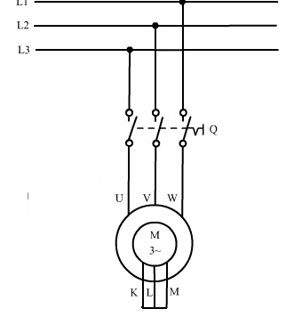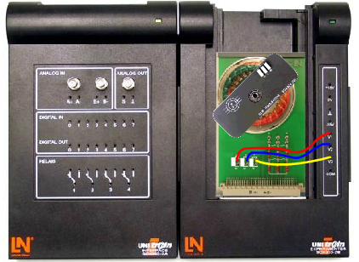

**Fig 6.3 Slip Ring Machine with Shorted rotor windings**

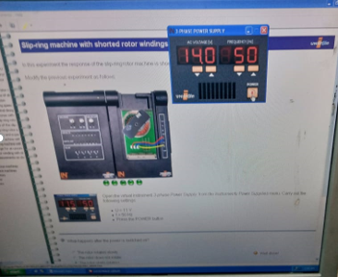

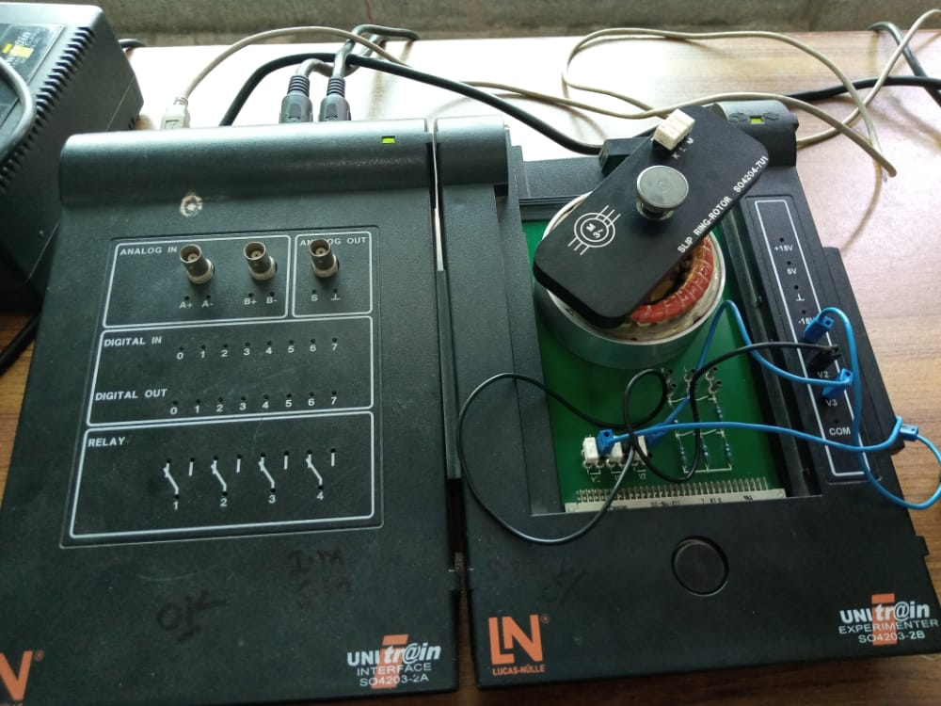

**Observations:**

**Top of Form**

**Q. What do you observe?**

1.Rotor rotates slowly

2.Rotor does not rotate

3**.Rotor starts rotating**

**Top of Form**

|  |  |  |  |  |
| --- | --- | --- | --- | --- |
| **Q. What is the reason for this response?**  1.No current can flow due to the disconnected rotor winding. Since no current is flowing, there can be no torque generated and thus no rotation.  2.The short circuit interferes with the operation  3**.Due to the short-circuit current a magnetic field arised which in conjunction with the external magnetic field generates a torque.**  **iii) Voltage at rotor for unconnected rotor winding:**  **Procedure:**   1. In this experiment we measure the no-load voltage of the rotor winding connected in open circuit and compare it to the stator voltage. 2. Connect the apparatus as shown in fig. 6.4. 3. Open the virtual instrument *3-phase Power Supply* from the *Instruments Power Supplies* menu. Carry out the following settings: U = 11 V ,f = 50 Hz 4. Press the POWER button 5. Open the virtual instrument Oscilloscope from the Instruments Meters menu. Carry out the following settings: 6. Channel A: 5 V/DIV, DC 7. Channel B: 10 V, DC 8. Time base: 5 ms 9. Trigger: Channel B 10. Copy the trace into the grid.   **Circuit Diagram:**    Fig 6.4 Slip ring machine with unconnected rotor winding  **Observations:**   |  |  | | --- | --- | |  |  | |  |  |   Read off the peak values of both voltages and copy them into the appropriate boxes!  Channel A: Rotor voltage VKL = 50V  Channel B: Stator voltage V12 = 14v  **Lab Exercise:**  ***Task 6.1:***Make a comparison between unconnected rotor winding and shorted rotor winding and also tell the reason for different response.  **Conclusions:** Describe your Comments in the space given below**.** |
|  |
|  |

|  |  |
| --- | --- |
| **Name** | Muhammad Asad |
| **Reg. #** | 2019-EE-383 |
| **Marks** |  |

**EXPERIMENT# 10 (b)**

**Slip Ring Machines with Starting Resistors**

**Objectives:**

* 1. Slip ring machines with starting resistors.
  2. Measurements of voltage on stator and rotor.

**Apparatus:**

1. Slip ring machine card
2. Lucas-Nulle unitrain module
3. PC
4. Connecting wires

**Theory:**

Slip ring machine along with starting resistors can be easily controlled via varying the resistor values. Furthermore these starting resistors help in increasing starting torque and limiting starting current.

**i)Slip ring machines with starting resistors:**

**Procedure:**

In this experiment the no-load voltage of the rotor winding with starter resistors is measured and compared to the stator voltage. The slip and the rotation speed are calculated.

1. Connect the circuit as shown in figure 10.1.
2. Open the virtual instrument *3-phase Power Supply* from the *Instruments Power Supplies* menu. Carry out the following settings: U = 11 V ,f = 50 Hz
3. Press the POWER button
4. Open the virtual instrument Oscilloscope from the Instruments Meters menu. Carry out the following settings:
5. Channel A: 5 V/DIV, DC
6. Channel B: 10 V, DC
7. Time base: 5 ms
8. Trigger: Channel B
9. Copy the trace into the grid.

**Circuit Diagram:**

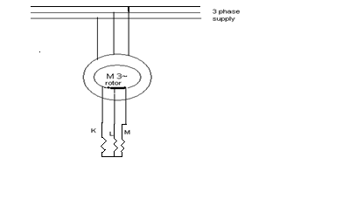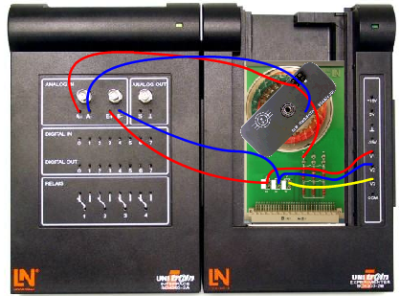

Fig 10.1 Slip Ring Machines with starting Resistors

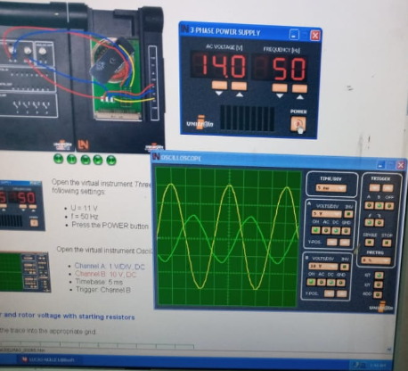

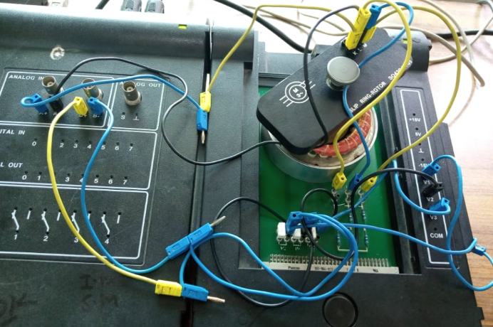

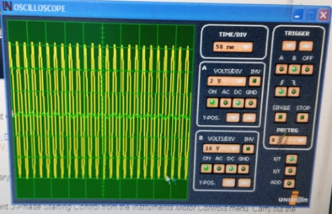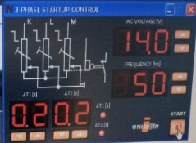

**Observations:**

Stator and rotor voltage with starting resistors Copy the trace into the grid.

Read out the peak values of the two voltages

Channel A: Rotor voltage =\_\_\_5\_\_\_V

Channel B: stator voltage   U12 =\_\_\_20\_\_\_\_\_V

Also read off the period duration of the two voltages and calculate the frequencies f = 1/T.

Channel A: Frequency of the rotor voltage  f2 =

Channel B: Frequency of the stator voltage  f1 =

Compute the slip based on the measured frequency values:

|  |
| --- |
| s = (f1 - f2) / f1 = |

Compute the speed:

|  |  |  |  |  |  |
| --- | --- | --- | --- | --- | --- |
| n = 60 \* f1 \* (1 - s) / p = \_\_\_\_\_\_\_\_\_\_rpm   |  |  | | --- | --- | | Stroboskop_blitz | Connect the stroboscope to the BNC socket of ANALOG OUT. | | Stroboskop | Open the virtual instrument *Stroboscope* from the *Instruments* menu.  Set it to the speed value calculated above. Push the POWER button |   Now measure the actual rotation speed by increasing or reducing the strobe frequency step-by-step until you have an image that appears to stand still:   |  | | --- | | n =\_\_\_\_\_\_\_rpm. | |
| **Lab Exercise:**  ***Task 7.1:*** Compare the speed of short circuited slip ring machine with starting resistors slip ring machine and describe reason of this difference.  **Conclusions:** Write your comments in the space provided below |

